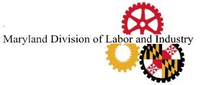
CERTIFICATION OF POSTING
THE WAGE REQUIREMENTS NOTICE

Contract Number:

Contract Description:
Dear (General Contractor’s Name)
As the general contractor, your firm must certify that the document entitled “Notice to Employees” will be conspicuously posted at the worksite so that the covered employees are informed about the wage requirements under State law. Certification of this posting is required prior to contract execution. The notice is to be provided in English, Spanish, and any other language commonly used by employees at the worksite.

Please sign below and return this page to the Commissioner of Labor and Industry, Department of Labor, Licensing and Regulation, 10946 Golden West Drive, Ste. 160, Hunt Valley, MD. 21031
.
By signing below, your firm is certifying that the “Notice to Employees” will be posted in each of the required languages. This posting must take place upon execution of the contract.

Location of Posting (please be specific:

Printed Name Signature

Title

Date

Department of Labor
Division of Labor and Industry
Living Wage Unit
10946 Golden West Drive, Ste. 160
Hunt Valley, MD. 21031
Telephone Number: (410) 767-2232
E-mail: dldlilivingwage-dllr@maryland.gov

Rev. 6/2022

