MARYLAND ADULT EDUCATION PROGRAMS - ADULT EDUCATION & LITERACY SERVICES

ALLEGANY COUNTY
Allegany College of Maryland
Center for Continuing Education & Workforce Development
12401 Willowbrook Road., S.E.
Cumberland, MD 21502
Phone: 301-784-5446

ANNE ARUNDEL COUNTY
Anne Arundel Community College
Sales and Service Training Center
7000 Arundel Mills Circle
Hanover, Maryland 21076
Phone: 410-777-1823

BALTIMORE CITY
Baltimore City Community College
Adult Basic Education & Literacy Services
710 East Lombard Street
Baltimore, Maryland 21202
Phone: 410-986-5449

Learning is For Tomorrow (LIFT)
901 North Milton Avenue, Ste. 210
Baltimore, Maryland 21205
Phone: 410-522-1705

South Baltimore Learning Center (SBLC)
28 E. Ostend Street
Baltimore, Maryland 21230
Phone: 410-625-4215

Strong City Baltimore
Adult Learning Center
2101 East Biddle Street
Baltimore, Maryland 21213
Phone: 410-261-3517

BALTIMORE COUNTY
Community College of Baltimore County
Center for Adult & Family Literacy
7200 Sollers Point Road
Baltimore, Maryland 21222
Phone: 443-840-4259

CARROLL COUNTY
Carroll Community College
224 North Center Street, Room 105AWestminster, Maryland 21157
Phone: 410-386-8630

CECIL COUNTY
Cecil College – The Elkton Center
107 Railroad Avenue
Elkton, Maryland 21921
Phone: 410-287-1078

FREDERICK COUNTY
Frederick Community College
7932 Opossumtown Pike
Frederick, Maryland 21702
Phone: 240-629-7962

GARRETT COUNTY
Garrett College
687 Mosser Road
McHenry, Maryland 21541
Phone: 301-387-3770

HARFORD COUNTY
Harford Community College
401 Thomas Run Road
Bel Air, Maryland 21015
Phone: 443-412-2616

HOWARD COUNTY
Howard Community College
10650 Hickory Ridge Road
Columbia, Maryland 21044
Phone: 443-518-4919

Howard County Library System Project Literacy
10375 Little Patuxent Parkway
Columbia, MD 21044
Phone: 410-313-7900

MONTGOMERY COUNTY
Montgomery College
Mannakee Building
900 Hungerford Drive, Suite 235
Rockville, Maryland 20850
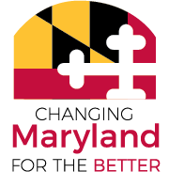
Phone: 240-567-8950

Literacy Council of Montgomery County
21 Maryland Avenue, Suite 320
Rockville, Maryland 20850
Phone: 240-665-0471

PRINCE GEORGE’S COUNTY
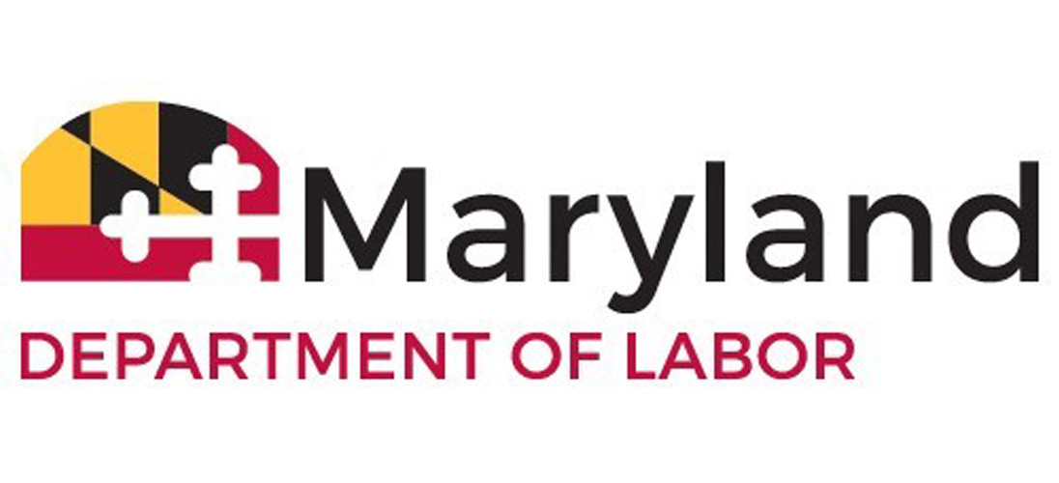
Prince George’s Community College
301 Largo Road,
Building Annex C, Office 011
Largo, Maryland 20774
Phone: 301-546-0891
labor.maryland.gov

SOMERSET COUNTY
Somerset County Public Schools
7994 Tawes Campus Drive
Westover, Maryland 21871
Phone: 410-651-2285

SOUTHERN MD

Charles, Calvert & St. Mary’s Counties
College of Southern Maryland
22950 Hollywood Road
Leonardtown, MD 20650
PHONE: 301-934-7770

UPPER SHORE
Caroline, Dorchester, Kent, Queen Anne’s & Talbot Counties
Chesapeake College
1000 College Circle
Wye Mills, MD 21679
Phone: 410-827-5929

WASHINGTON COUNTY
Hagerstown Community College
11400 Robinwood Drive
Hagerstown, Maryland 21742
PHONE: 240-500-2313

WICOMICO COUNTY
Wor-Wic Community College
32000 Campus Drive
Salisbury, Maryland 21804
Phone: 410-334-2815

WORCESTER COUNTY
Worcester County Public Schools
6270 Worcester Highway
Newark, Maryland 21841
PHONE: 410-632-5071

